**DS LAB 07 QUEUES**

**TASK 1**

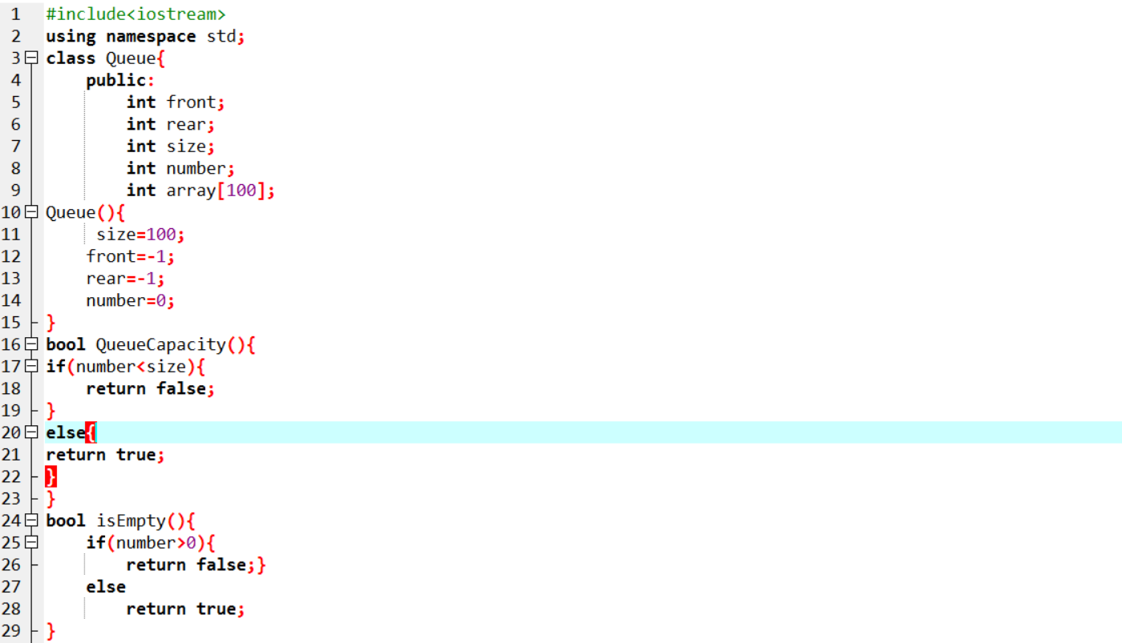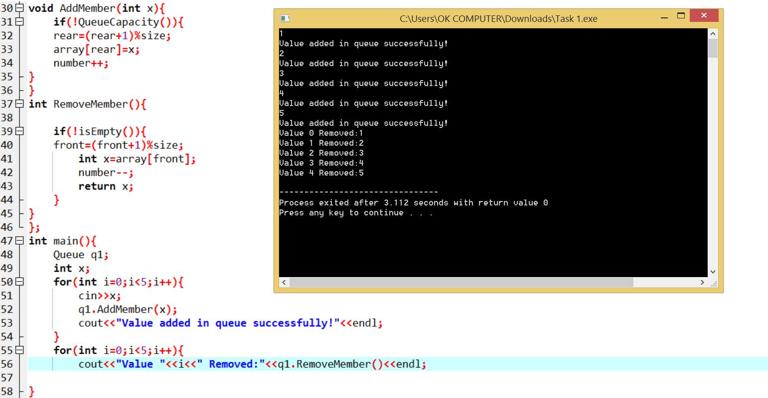

**TASK 2**

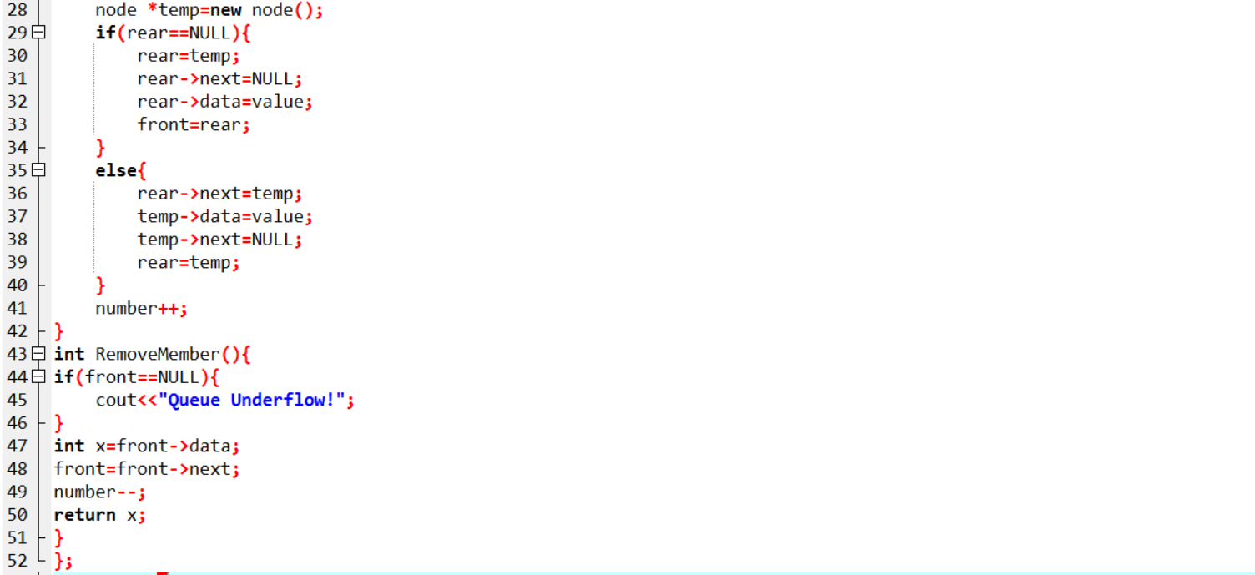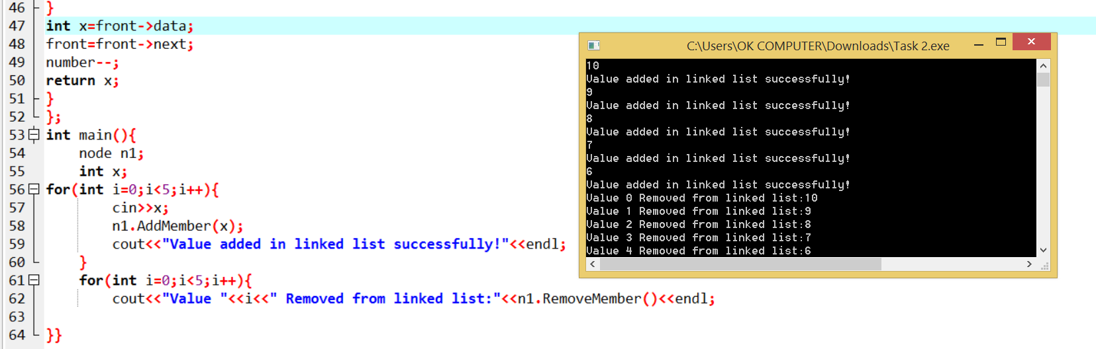

**TASK 3**

